823910Unit III – Python Basics and Data Structures
Experiment 1: String Operations
• Aim: Perform operations on strings.
• Objectives: Learn string methods, slicing, and formatting.
• Theory: Strings are immutable sequences; Python provides many built-in methods.
• PYTHON CODE:
# String Operations
s = 'DataScience'
print("Original String:", s)
print("Uppercase:", s.upper())
print("Lowercase:", s.lower())
print("Sliced (0:4):", s[0:4])
print("Replace 'Science' with 'Analytics':", s.replace('Science',
'Analytics'))
print("Check if string starts with 'Data':", s.startswith('Data'))
print("Check if string ends with 'Science':", s.endswith('Science'))
print("Split string by 'a':", s.split('a'))
EXPECTED OUTCOME:
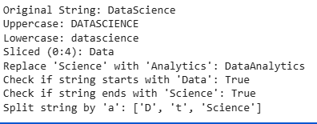
Experiment 2: List Manipulations
• Aim: Perform operations on lists.
• Objectives: Append, remove, sort, reverse, and slice lists.
• Theory: Lists are mutable sequences that allow dynamic operations.
• PYTHON CODE:

# List Operations
lst = [5, 2, 9, 1]
print("Original List:", lst)
lst.append(7)
print("After append 7:", lst)
lst.insert(2, 15)
print("After insert 15 at index 2:", lst)
lst.remove(2)
print("After removing 2:", lst)
lst.sort()
print("Sorted List:", lst)
lst.reverse()
print("Reversed List:", lst)
print("Sliced List (1:4):", lst[1:4])
EXPECTED OUTCOME
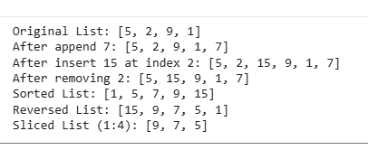
Experiment 3: Dictionary Operations
• Aim: Work with key-value pairs.
• Objectives: Add, update, delete, and iterate over dictionaries.
• Theory: Dictionaries store mappings of unique keys to values.
• PYTHON CODE:
# Dictionary Operations
d = {'a':1, 'b':2}
print("Original Dictionary:", d)
d['c'] = 3
print("After adding 'c':3:", d)
d['a'] = 5
print("After updating 'a':", d)
d.pop('b')
print("After removing 'b':", d)
print("Keys:", d.keys())
print("Values:", d.values())
print("Items:", d.items())
# Iterating through dictionary
for key, value in d.items():
print(f"Key: {key}, Value: {value}")
EXPECTED OUTCOME

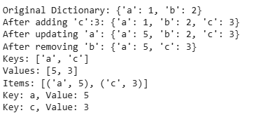
Experiment 4: Tuple and Set Operations
• Aim: Perform operations on tuples and sets.
• Objectives: Understand immutability of tuples and set operations.
• Theory: Tuples are immutable sequences, sets are unordered collections of unique
items.
• PYTHON CODE:
# Tuple Operations
t = (1, 2, 3)
print("Tuple:", t)

print("Access index 1:", t[1])
print("Count of 2:", t.count(2))
print("Index of 3:", t.index(3))

EXPECTED OUTCOME
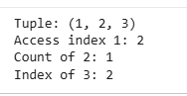
# Set Operations
s = {1, 2, 3}
print("Original Set:", s)
s.add(4)
print("After adding 4:", s)
s.remove(2)
print("After removing 2:", s)
print("Set Union:", s.union({5,6}))
print("Set Intersection:", s.intersection({3,4,5}))
print("Set Difference:", s.difference({3,5}))

EXPECTED OUTCOME
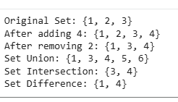

Experiment 5: File Handling in Python
• Aim: Read from and write to text files.
• Objectives: Learn file input/output operations.
• Theory: Python provides open(), read(), write(), and context managers (with) for
file handling.
• PYTHON CODE:
filename = 'data.txt'

# Writing to file
with open(filename, 'w') as f:
f.write("Hello Data Science\n")
f.write("Python File Handling Example\n")

# Reading file content
with open(filename, 'r') as f:
content = f.read()
print("File Content:\n", content)

# Appending to file
with open(filename, 'a') as f:
f.write("Appending new line\n")

# Reading updated file
with open(filename, 'r') as f:
updated_content = f.read()
print("Updated File Content:\n", updated_content)
EXPECTED OUTCOME

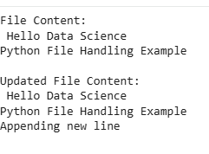

Unit II – Modeling Methods
Experiment 6: K-Means Clustering
• Aim: Apply K-Means algorithm to cluster a dataset.
• Objectives:
1. Understand clustering concepts.
2. Implement K-Means algorithm using Python.
3. Visualize clusters and centroids.
• Theory: K-Means partitions data into k clusters by minimizing distance to cluster
centroids. Commonly used for unsupervised learning.
• PYTHON CODE
# K-Means Clustering
from sklearn.cluster import KMeans
import matplotlib.pyplot as plt
import numpy as np
# Sample dataset
X = np.array([[1,2], [1,4], [1,0], [4,2], [4,4], [4,0]])
# KMeans model
kmeans = KMeans(n_clusters=2, random_state=42)
kmeans.fit(X)
# Cluster centers
print("Cluster Centers:\n", kmeans.cluster_centers_)
# Labels
print("Cluster Labels:", kmeans.labels_)
# Plotting clusters
plt.scatter(X[:,0], X[:,1], c=kmeans.labels_, cmap='rainbow')
plt.scatter(kmeans.cluster_centers_[:,0], kmeans.cluster_centers_[:,1],
marker='x', s=200, color='black')
plt.title('K-Means Clustering')
plt.xlabel('X-axis')
plt.ylabel('Y-axis')
plt.show()

EXPECTED OUTCOME
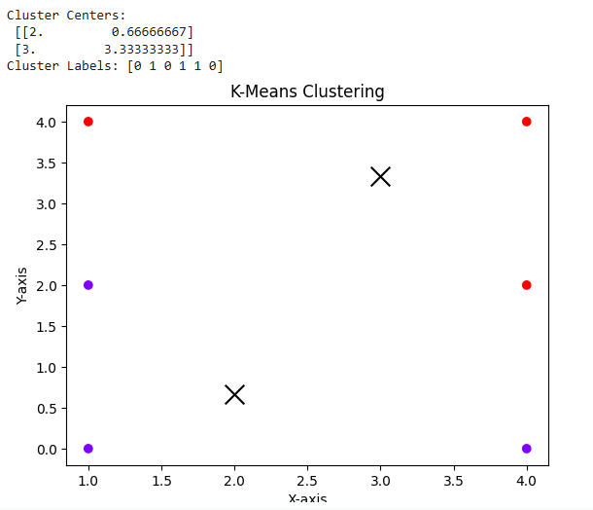
Experiment 7: Classification using Naïve Bayes
• Aim: Implement Naïve Bayes classifier for classification.
• Objectives:
1. Apply probabilistic classification.
2. Evaluate classifier accuracy.
• Theory: Naïve Bayes assumes independence among predictors and applies Bayes’
theorem to compute class probabilities.
• PYTHON CODE:
# Naive Bayes Classification
from sklearn.datasets import load_iris
from sklearn.model_selection import train_test_split
from sklearn.naive_bayes import GaussianNB
from sklearn.metrics import accuracy_score, classification_report
# Load dataset
iris = load_iris()
X = iris.data
y = iris.target
# Split data
X_train, X_test, y_train, y_test = train_test_split(X, y, test_size=0.3,
random_state=42)
# Model training
model = GaussianNB()
model.fit(X_train, y_train)
# Prediction
y_pred = model.predict(X_test)
# Evaluation
print("Accuracy:", accuracy_score(y_test, y_pred))
print("Classification Report:\n", classification_report(y_test, y_pred))
EXPECTED OUTCOME
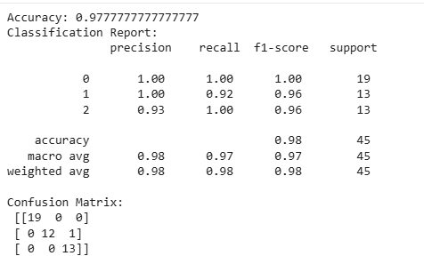

Experiment 8: Linear Regression
• Aim: Predict continuous output using linear regression.
• Objectives:
1. Train linear regression model.
2. Predict and evaluate outputs.
• Theory: Linear regression models relationship between independent (X) and
dependent (y) variables using a line of best fit.
PYTHON CODE
# Linear Regression

from sklearn.linear_model import LinearRegression
import numpy as np
# Sample data
X = np.array([[1],[2],[3],[4],[5]])
y = np.array([2,4,5,4,5])
# Model training
model = LinearRegression()
model.fit(X, y)
# Predictions
predicted = model.predict(X)
print("Coefficients:", model.coef_)
print("Intercept:", model.intercept_)
print("Predictions:", predicted)
# Predict new value
new_pred = model.predict([[6]])
print("Prediction for X=6:", new_pred)
EXPECTED OUTCOME
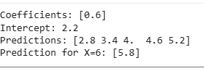

Experiment 9: Logistic Regression
• Aim: Perform binary classification using logistic regression.
• Objectives:
1. Train logistic regression model.
2. Predict binary outcomes.
• Theory: Logistic regression uses the sigmoid function to model probabilities of a
binary response.
PYTHON CODE
# Logistic Regression
from sklearn.linear_model import LogisticRegression
# Sample dataset
X = [[0],[1],[2],[3],[4],[5]]
y = [0,0,0,1,1,1]
# Model training
model = LogisticRegression()
model.fit(X, y)
# Prediction
y_pred = model.predict([[1.5], [3.5]])
print("Predictions:", y_pred)
# Probability
print("Predicted Probabilities:\n", model.predict_proba([[1.5],[3.5]]))
EXPECTED OUTCOME
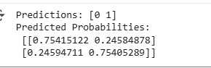

Experiment 10: Model Evaluation using Confusion Matrix
• Aim: Evaluate classifier performance using confusion matrix.
• Objectives:
1. Compute confusion matrix.
2. Generate classification metrics (precision, recall, F1-score, accuracy).
• Theory: Confusion matrix summarizes classification performance; each cell shows counts of predicted vs actual
PROGRAM CODE

# Confusion Matrix
from sklearn.metrics import confusion_matrix, classification_report
# Sample true and predicted labels
y_true = [0,1,0,1,0,1]
y_pred = [0,1,0,0,0,1]
# Confusion matrix
cm = confusion_matrix(y_true, y_pred)
print("Confusion Matrix:\n", cm)
# Classification report
print("Classification Report:\n", classification_report(y_true, y_pred))
EXPECTED OUTCOME

Unit IV – Simulated MapReduce using Python
Experiment 11: Word Count
• Aim: Count word frequencies using MapReduce logic in Python.
• Objectives:
1. Understand Map, Shuffle, Reduce phases.
2. Implement word frequency counting using Python.
• Theory:
Map emits key-value pairs (word, 1), Shuffle groups by key, Reduce aggregates
counts per key.
• PYTHON CODE:
from collections import defaultdict
# Sample text

lines = [
'data science python',
'python is powerful',
'data analysis'
]
# Map phase
mapped = [(word, 1) for line in lines for word in line.split()]
# Shuffle phase
shuffled = defaultdict(list)
for k, v in mapped:
shuffled[k].append(v)
# Reduce phase
reduced = {k: sum(v) for k, v in shuffled.items()}
print("Word Count:", reduced)

EXPECTED OUTCOME
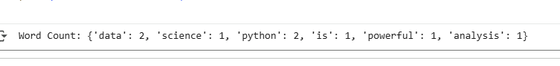
Experiment 12: Average Temperature by City
• Aim: Compute average temperature per city using MapReduce logic.
• Objectives:
1. Group data by city.
2. Calculate aggregated average.
• Theory: Map emits (city, temperature), Shuffle groups by city, Reduce computes
Averages.
PYTHON CODE:
from collections import defaultdict
# Sample data
data = [
('Chennai', 35),
('Delhi', 40),
('Chennai', 34),
('Delhi', 38)
]
# Shuffle phase
shuffled = defaultdict(list)
for city, temp in data:
shuffled[city].append(temp)
# Reduce phase: calculate average
averages = {city: sum(temps)/len(temps) for city, temps in
shuffled.items()}
print("Average Temperatures by City:", averages)

EXPECTED OUTCOME

Experiment 13: Inverted Index
• Aim: Build an inverted index mapping words to documents.
• Objectives:
1. Learn indexing of documents using MapReduce logic.
2. Understand word-document relationship.
• Theory: Map emits (word, doc_id), Shuffle groups by word, Reduce aggregates
unique document IDs.
PYTHON CODE

# Experiment 13: Inverted Index
from collections import defaultdict
# Sample documents
docs = {
'doc1': 'data python',
'doc2': 'python machine',
'doc3': 'data analysis'
}
# Map & Shuffle
shuffled = defaultdict(list)
for doc_id, text in docs.items():
for word in text.split():
shuffled[word].append(doc_id)
# Reduce phase: unique document IDs per word
inverted_index = {word: list(set(doc_ids)) for word, doc_ids in
shuffled.items()}
print("Inverted Index:", inverted_index)
EXPECTED OUTCOME
Experiment 14: Matrix–Vector Multiplication
• Aim: Multiply a matrix with a vector using MapReduce logic.
• Objectives:
1. Apply MapReduce approach to linear algebra computation.
2. Understand distributed aggregation concept.
• Theory: Map emits partial products, Shuffle groups by row, Reduce sums them.
PYTHON CODE
from collections import defaultdict

# Matrix as dictionary {(row,col): value}
A = {(0,0): 1, (0,1): 2, (1,0): 3, (1,1): 4}
# Vector as dictionary {col: value}
B = {0: 5, 1: 6}
# Map phase
mapped = [(i, A[i,j]*B[j]) for (i,j) in A]
# Shuffle phase
shuffled = defaultdict(list)
for i, val in mapped:
shuffled[i].append(val)
# Reduce phase
result = {i: sum(vals) for i, vals in shuffled.items()}
print("Matrix-Vector Multiplication Result:", result)
EXPECTED OUTCOME
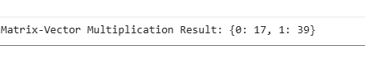
Experiment 15: Sorting by Key
• Aim: Sort key-value pairs by key using MapReduce logic.
• Objectives:
1. Implement sorting in Reduce phase.
2. Aggregate values by key.
• Theory: Map emits (key, value), Shuffle groups by key, Reduce aggregates and sorts
Keys.
PYTHON CODE

# Experiment 15: Sorting by Key
from collections import defaultdict
# Sample data
data = [('b', 2), ('a', 5), ('b', 1), ('c', 3)]
# Shuffle phase
shuffled = defaultdict(list)
for k, v in data:
shuffled[k].append(v)
# Sort keys and reduce
sorted_keys = sorted(shuffled.keys())
reduced = {k: sum(shuffled[k]) for k in sorted_keys}
print("Sorted and Aggregated by Key:", reduced)

EXPECTED OUTCOME

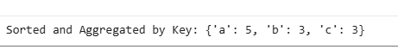

Unit V – Data Visualization
Experiment 16: Line and Bar Charts
• Aim: Plot line and bar charts to visualize data trends.
• Objectives:
1. Learn to plot line charts.
2. Learn to plot bar charts.
3. Customize colors, labels, and legends.
• Theory: Line charts display trends over data points, bar charts compare values across
Categories.
PYTHON CODE
# Experiment 16: Line and Bar Charts
import matplotlib.pyplot as plt
# Sample data
x = [1, 2, 3, 4]
y = [10, 20, 15, 25]
# Line Chart
plt.figure(figsize=(8,4))
plt.plot(x, y, marker='o', color='b', label='Line Chart')
plt.title('Line Chart Example')
plt.xlabel('X-axis')
plt.ylabel('Y-axis')
plt.legend()
plt.grid(True)
plt.show()
# Bar Chart
plt.figure(figsize=(8,4))
plt.bar(x, y, color='g', label='Bar Chart')
plt.title('Bar Chart Example')
plt.xlabel('X-axis')
plt.ylabel('Y-axis')
plt.legend()
plt.show()
EXPECTED OUTCOME

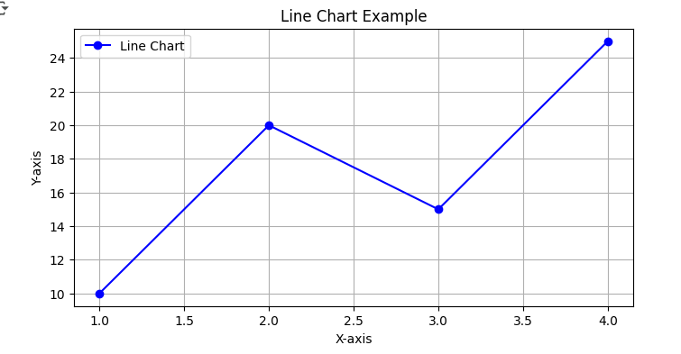

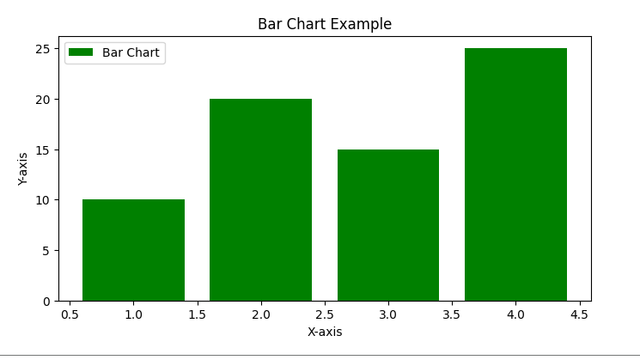

Experiment 17: Histograms and Boxplots
• Aim: Visualize data distribution using histogram and boxplot.
• Objectives:
1. Display frequency distribution.
2. Analyze data spread, median, and outliers.
• Theory: Histogram shows frequency, boxplot shows quartiles and outliers.
PYTHON CODE
import matplotlib.pyplot as plt

# Sample data
data = [10, 20, 15, 25, 30, 35, 40, 45, 50]
# Histogram
plt.figure(figsize=(8,4))
plt.hist(data, bins=5, color='skyblue', edgecolor='black')
plt.title('Histogram Example')
plt.xlabel('Value')
plt.ylabel('Frequency')
plt.show()
# Boxplot
plt.figure(figsize=(8,4))
plt.boxplot(data, patch_artist=True)
plt.title('Boxplot Example')
plt.show()
EXPECTED OUTCOME
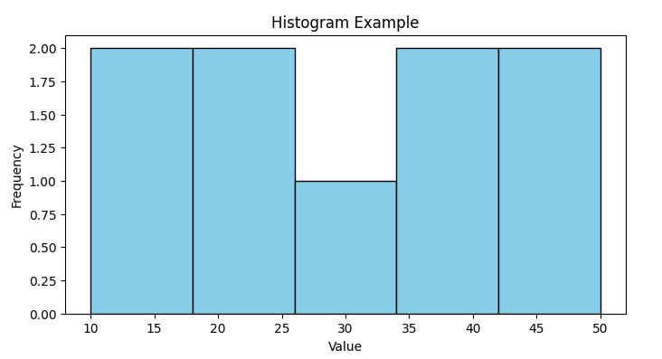

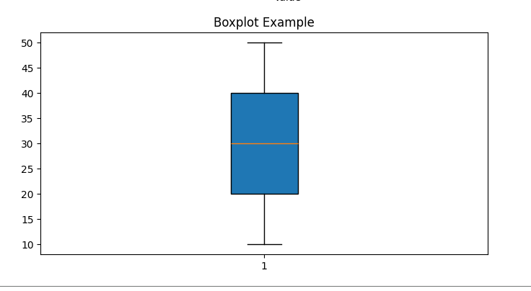

Experiment 18: Scatter Plot and Correlation Analysis
• Aim: Visualize relationship between two variables using scatter plot.
• Objectives:
1. Identify patterns or correlations.
2. Customize plot markers and colors.
• Theory: Scatter plot shows correlation or spread of two variables.
• Python Code:
# Experiment 18: Scatter Plot
import matplotlib.pyplot as plt
# Sample data
x = [1, 2, 3, 4, 5]
y = [2, 4, 1, 3, 5]
plt.figure(figsize=(8,4))
plt.scatter(x, y, color='red', marker='x')
plt.title('Scatter Plot Example')
plt.xlabel('X-axis')
plt.ylabel('Y-axis')
plt.grid(True)
plt.show()

EXPECTED OUTCOME
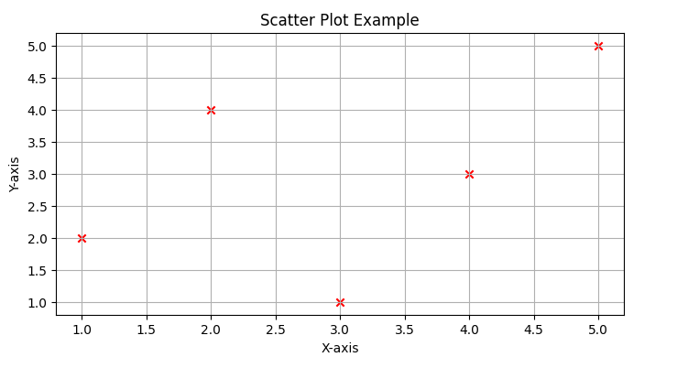

Experiment 19: Time Series Visualization
• Aim: Plot data trends over time.

• Objectives:
1. Understand sequential data visualization.
2. Use matplotlib to handle dates.
• Theory: Time series plots visualize trends or patterns over sequential intervals.
PYTHON CODE
# Experiment 19: Time Series Plot
import matplotlib.pyplot as plt
import matplotlib.dates as mdates
from datetime import datetime
# Sample dates and values
dates = ['2025-10-01', '2025-10-02', '2025-10-03', '2025-10-04']
values = [100, 110, 105, 115]
# Convert string dates to datetime objects
dates = [datetime.strptime(date, "%Y-%m-%d") for date in dates]
plt.figure(figsize=(8,4))
plt.plot(dates, values, marker='o', color='purple')
plt.title('Time Series Plot Example')
plt.xlabel('Date')
plt.ylabel('Value')
plt.gca().xaxis.set_major_formatter(mdates.DateFormatter('%Y-%m-%d'))
plt.gcf().autofmt_xdate()

Experiment 20: Geographic Data Visualization
• Aim: Visualize data points on a map using latitude and longitude.
• Objectives:
1. Understand basic geospatial plotting.
2. Plot locations using matplotlib scatter.
• Theory: Simple coordinate-based visualization without advanced mapping libraries.
PYTHON CODE
# Experiment 20: Geographic Data Visualization
import matplotlib.pyplot as plt
# Sample coordinates (Latitude, Longitude)
lat = [12.9716, 13.0827, 13.0674]
lon = [77.5946, 80.2707, 80.2376]
cities = ['Bangalore', 'Chennai', 'Vellore']
plt.figure(figsize=(8,5))
plt.scatter(lon, lat, color='blue', s=100)
# Annotate city names
for i, city in enumerate(cities):
plt.text(lon[i]+0.1, lat[i]+0.05, city)

plt.title('Geographic Data Visualization')
plt.xlabel('Longitude')
plt.ylabel('Latitude')
plt.grid(True)
plt.show()
EXPECTED OUTCOME

